Rob Campbell

Homework 3

1. Completed
2. A) In-vitro SELEX-seq is used to characterize DNA-binding specificities of Hox-based multiprotein complexes outside of a living organism in a laboratory. PBM is a type of software that allows the user to manipulate small complexes interactively. In-vivo ChIP-seq is used to analyze protein interactions with DNA inside a cell. The benefits of SELEX-seq is that the variables can be comtrolled because it takes place outside of the cell but the disadvatages are that you cannot see actual interactions in nature. The benefit of ChIP-seq in vivo is that you can see how interactions normally will take place but you cannot control every variable.
3. Completed
4. Code loaded to GitHub
5. 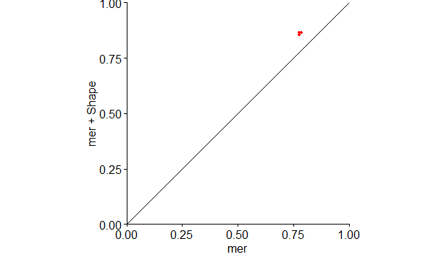
6. Completed
7. 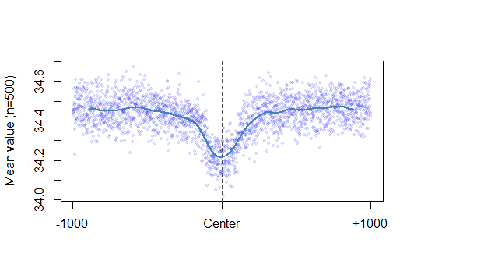

Figure : Helical Twist

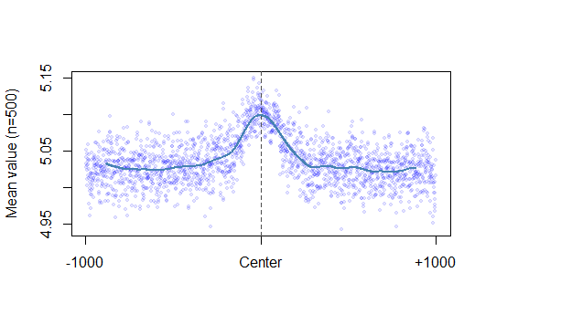

Figure :Minor Groove Width

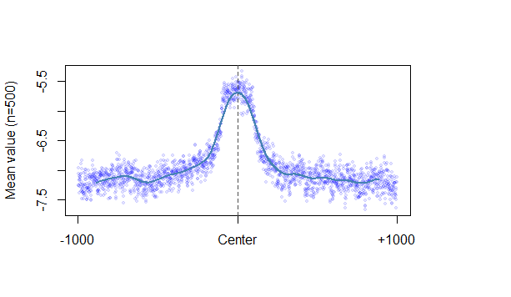

Figure : Propeller Twist

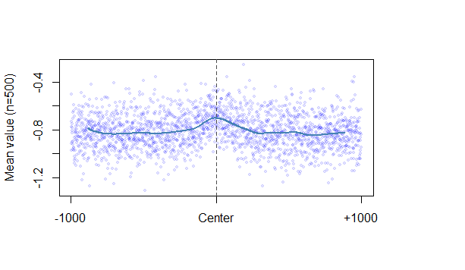

Figure :Roll

I learned from this that every differnet interaction will have a different center mean value. Also, the mean values for Roll and propeller twist are negative values and that helical twist and minor groove width is measured in positive mean values.

8.

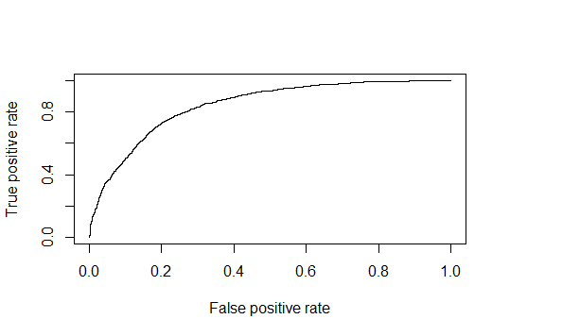

Figure ROC curve for 1-Mer + Shape AUC score = 0.840987

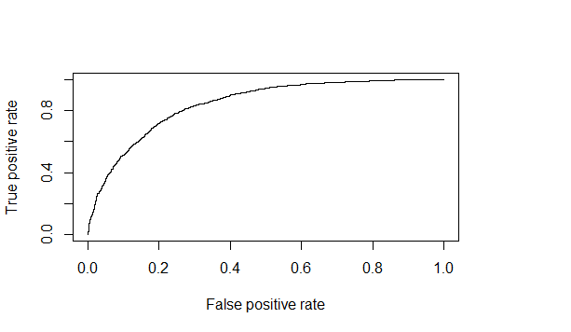

Figure ROC curve for 1-Mer. AUC score= 0.841501

I learned for number 8 that the 1-Mer + Shape is has a slightly higher AUC score than the 1-Mer AUC score. They are both reported in the captions.